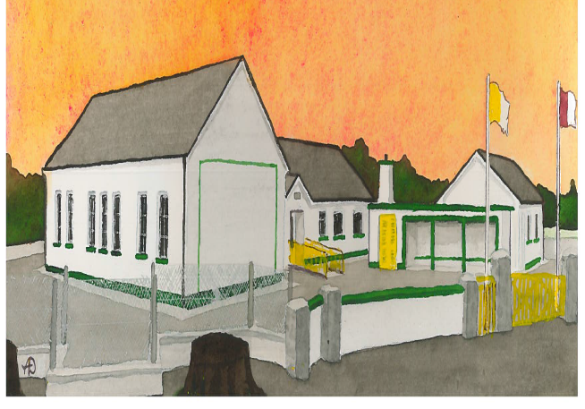
Board of Management Agreed Report 30th September 2025
Principals Report
- New Buildings – section 5 planning application made in early September, application has been refused but is being appealed based on Class 20b of the Planning and Development Act 2001.
Drainage survey has identified collapsed pipe causing issues with blockage of rainwater drain. Following negotiations with the Dept of Education our Waste Water System upgrade will not be included in our current project. We have applied to Emergency Works Scheme for our Waste Water System upgrade.
- Enrolments – 136 students, 9 students in our Special Classes and 127 in mainstream.
- Admissions Policy – has been updated in line with NCSE & Diocesan guidance, the policy was adopted by the BOM.
- Breakfast & Afterschool – the school is affiliated with the National Childcare Scheme and have applied for core funding for our service. Due to demand we have applied to TUSLA school age childcare and have applied to approve extra childcare spaces.
- Schools meals approval received for Dept of Social Protection.
- Parent Teacher meetings will take place in early November.
- School will be closed for Presidential election on October 24th.

